Mancala version 1.0.

Documentation.
25.11.2010

Minimum Requirements.

This software has tried out in the following conditions, so we would define mancalas minimum requirements as follows:
Processor: 1.4 GHz Celeron
Ram: 512 MB
Software needed to run this software:
jdk 1.6

How to install and run this software.

Software comes in a zip file, so one must extract the archinve, as follows :
[root@Majakas src]# unzip mancala_src.zip
Archive: mancala_src.zip

To run this software, one must simply follow this command in the correct folder.
[root@Majakas Mancala]# ls
bin doc generated Mancala.ctr mancala.jar pic src
[root@Majakas Mancala]# java -jar mancala.jar

Screenshots with explanations.

See Figure1. For the main menu. Following Items in the main menu can be defined as follows:
- Hot Seat Game – This is a gamemode for 2 players using the same computer. (Figure2.)
- Create Host – Will create a network game. (Figure3.)
  - Network game looks the exactly the same as ‘hot seat’ game
- Join Server – Will let user to join a network game, required thing in this case would be the game that exists. (Figure4.)
- Hostory Of Games - ?
- Exit – Will let player to exit the application

Figure1.
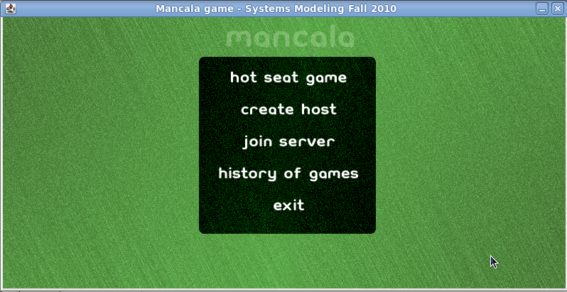
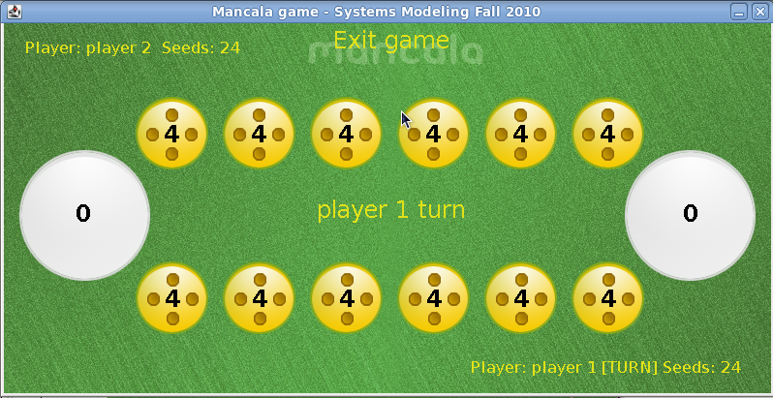
Figure2.

Figure3.
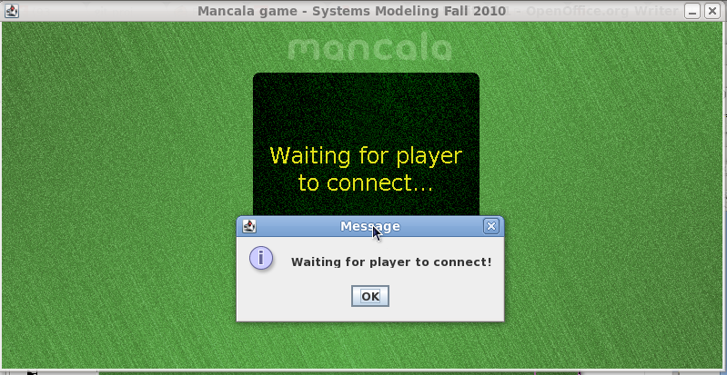
Figure4.
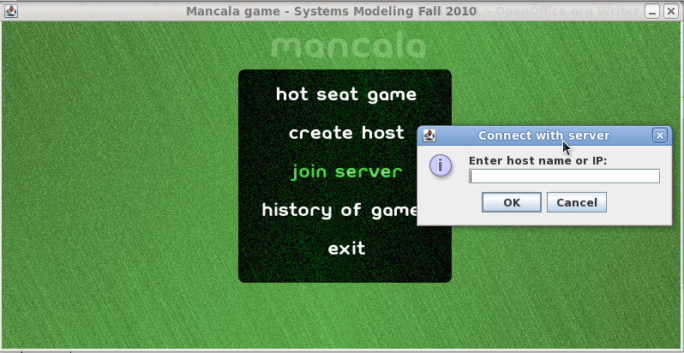

Rules of the game (Quoted from Wikipedia):
- At the beginning of the game, four seeds are placed in each pit. Stores are empty.
- Each player controls the six pits and their seeds on his side of the board. Players score is the number of seeds in the store to his right.
- Players take turns sowing their seeds. On a turn, the player removes all seeds from one of the pits under players control. Moving counter-clockwise, the player drops one seed in each pit in turn, including the player's own store but not his opponent's.
- If the last sown seed lands in the player's store, the player gets an additional move. There is no limit on the number of moves a player can make in his turn.
- If the last sown seed lands in an empty pit owned by the player, and the opposite house contains seeds, both the last seed and the opposite seeds are captured and placed into the player's store.
- When one player no longer has any seeds in any of his houses, the game ends. The other player moves all remaining seeds to his store, and the player with the most seeds in his store wins.

